ARTIFICIAL INTELLIGENCE
PROJECT

ARTIFICIAL INTELLIGENCE DIETICIAN

Made By:-
Akshit Bansal(15CSU019)
Akhil Goyal (15CSU016)

PROBLEM STATEMENT

The online artificial dietician is a bot with artificial intelligence about human diets.It acts as a diet consultant similar to a real dietician.Dieticians are educated with nutrient value of foods.A dietician consults a person based on his schedule,body type,height and weight.

OVERALL WORKING OF THE PROJECT

The system too asks all this data from the user and processes it.It asks about how many hour the user works,his height,weight,age etc.The system stores and processes this data and then calculates the nutrient value needed to fill up user needs.The system then shows an appropriate diet to the users and asks if user is ok with it,else it shows other alternate diets to fill up users needs.

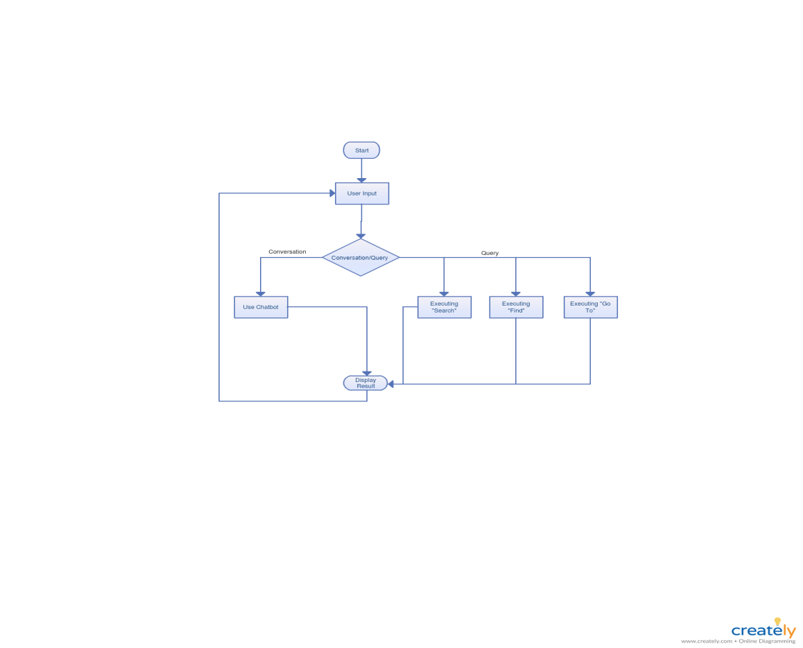

USE CASE DIAGRAM

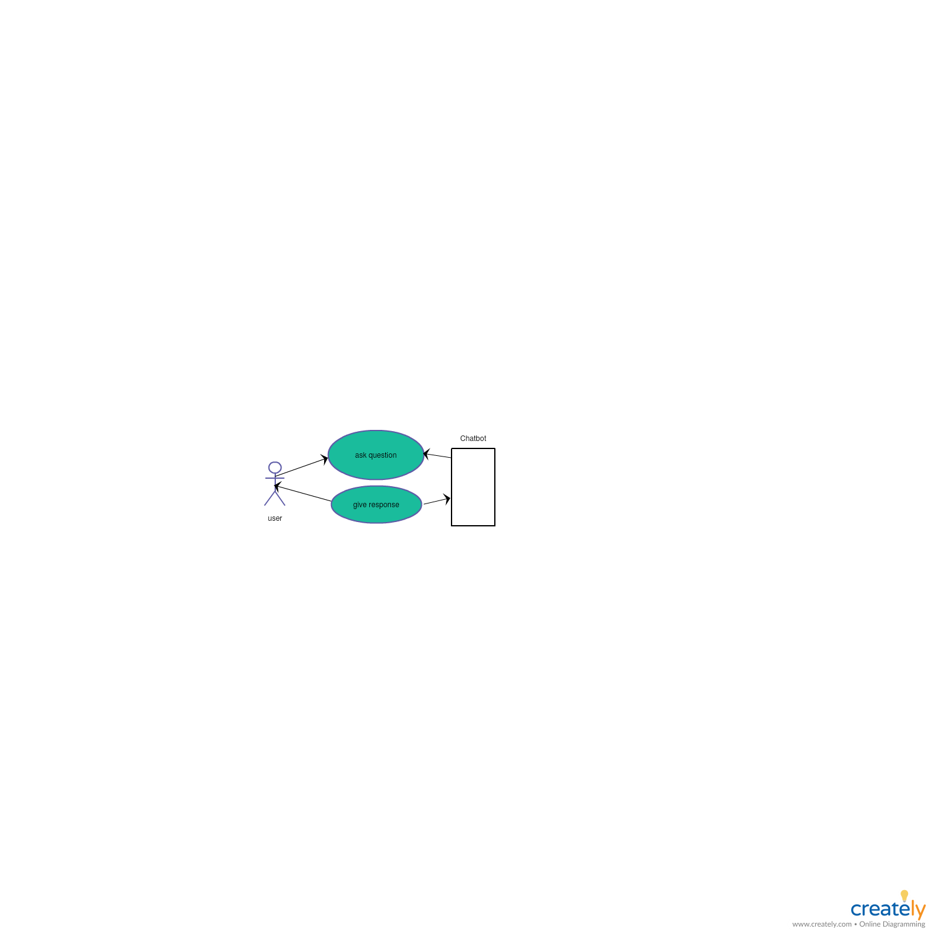

TECHNOLOGY USED TO DEVELOP THE GUI
Android
TECHNOLOGY USED TO DEVELOP THE BOT
- Android with firebase
2. Machine Learning.

GOALS ACHIEVED THROUGH THE PROJECT

- The application also eliminates the travelling cost in visiting a dietician.
- The usage of this application greatly reduces the time required to get the best diet plan as it is standalone application and there is no danger of one point failure.

